Acting on Multiple Sub-Tasks
The example below demonstrates how to 'Complete' a group of sub-tasks.

Step 0
Select the sub-tasks as normal on the Issue Navigator page.
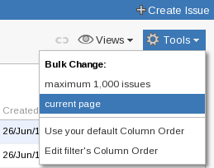
Illustration 1: The Tools drop down menu in the Issue Navigator page
Select the 'Tools' drop-down menu, situated on the right above the list of issues ((Illustration 1: The Tools drop down menu in the Issue Navigator page). From the 'Bulk Change' section of the menu select either 'all XXX issue(s)' or 'current page'. This will open the first page of the bulk action process (Illustration 2:Bulk Operation - Step 1).

Step 1
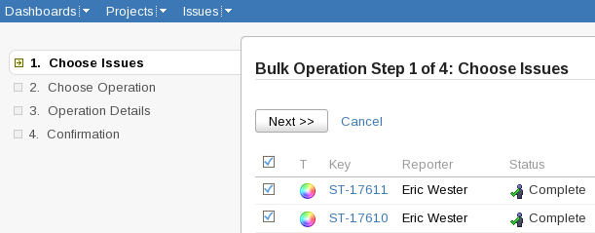
Illustration 2:Bulk Operation - Step 1
Use the tick-box in the header section of the table to select all of the sub-tasks.
Click 'Next>>'

Step 2
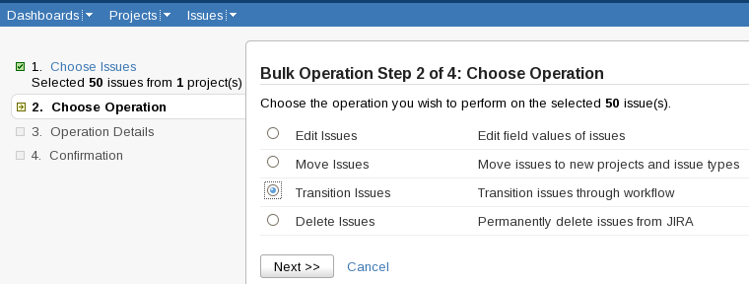
Illustration 3:Bulk Operation - Step 2
Select 'Transition Issues'
Click 'Next>>'

Step 3a
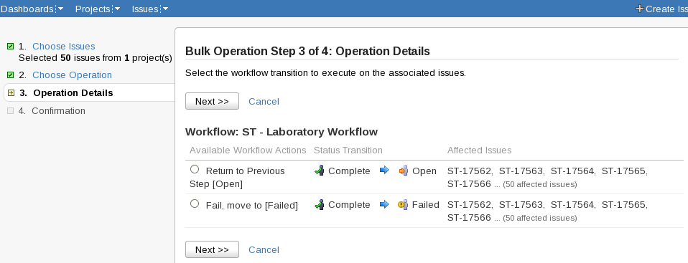
Illustration 4:Bulk Operation - Step 3a
Select the transition to carry out. An option is displayed for each transition that is available. Not all of the transitions will necessarily be available for all of the selected issues. Issues that cannot carry-out the transition will be removed from the selected group. Only one transition can be carried out at a time.
Click 'Next>>'

Step 3b
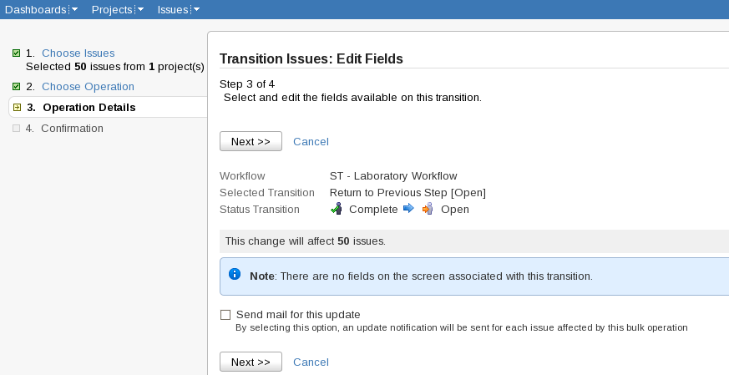
Illustration 5:Bulk Operation - Step 3b
The second page of the third step displays the form that would pop-up if this transition were performed manually. When there isn't such a form, as in the case above, this page can be ignored. In Sample Tracking the only time this is used is when transitioning samples to the Unresolved or Deprecated steps.
The 'Send mail for this update' box can be safely ignored. Email is disabled for all actions carried out in the Sample Tracking project.

Click 'Next>>'

Step 4
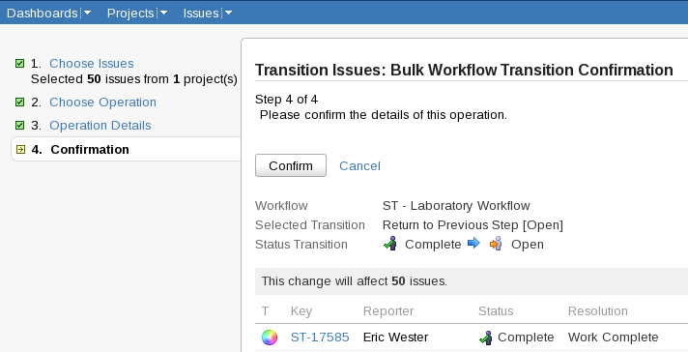
Illustration 6:Bulk Operation - Step 4
The final page summarizes the action that will take place and lists all of the issues that it will take place on. There is no undo in Jira. Check the details of the action before clicking 'Confirm'

